ABSTRACT
Velmurugan-Furnitures is a fully responsive browser-based furniture store prototype built with HTML, CSS, and JavaScript. It is designed for a physical shop that currently has no website or online sales facility. The system allows customers to browse furniture categories, view product details, add items to wishlist and cart, and submit purchase orders. When a user clicks the Buy button, the selected product details (name and price) along with the registered customer's delivery information (name, phone, address, pincode, and landmark) are automatically compiled and sent via email to the admin's email address (adilmuhammed47000@gmail.com) so the shop can process delivery and collect payment through cash on delivery (COD). The admin can also add and delete new products through a dedicated admin panel. Order email delivery is powered by FormSubmit.co, a completely free service that requires no backend server or API keys.
- INTRODUCTION

1.1 Overview of the Project
The primary objective of this project is to create an interactive digital furniture catalog and shopping system for Velmurugan Furnitures. The system bridges the gap between a traditional physical shop and an online presence by allowing visitors to browse furniture categories and product showcases without logging in, giving guests the ability to explore products without purchasing, supporting user registration and login for shopping actions, providing cart and wishlist functionality for saving items, automating order emails to the admin for delivery coordination, and offering admin controls for inventory management. The home page presents furniture categories for Living Room, Bedroom, Dining Room, and Office Furniture, and includes multiple product showcases such as Best Products, Best Deals, Trending, Top Rated Items, and Deal of the Day, along with a New Arrivals section for admin-added products.
1.2 MODULE DESCRIPTION
The project consists of several browser-based modules.
The main entry page, index.html, serves as the login portal for registered customers, offers options for new user registration, guest access, and admin login, and validates credentials stored in localStorage before redirecting authenticated users to the home page. The registration page, reg.html, captures customer profile details including username, password, phone number, delivery address, pincode, and landmark, saves the registration data in localStorage under the key `user`, and allows customers to create an account needed for purchase.

The main storefront page, home.html, displays furniture category dropdowns and multiple product showcases, includes a link to view admin-added New Arrivals, saves selected product information to localStorage when product images are clicked, and is built responsively for both mobile and desktop viewing. The New Arrivals page, newproducts.html, shows products added by the admin by loading them from the localStorage `products` array, and allows customers to add items to cart or wishlist or click Buy Now for immediate purchase. Each product tile displays an image, name, price, and action buttons.

The product details page, productdetails.html, displays detailed information for the selected product by reading from the localStorage `product` key, and presents the product image, name, price, and description for customer review. The shopping cart page, cart.html, displays all items added to the cart by loading them from the localStorage `cart` array, allows customers to remove items individually, and enables order placement from selected cart items by saving the product to localStorage and opening the order confirmation page. The wishlist page, wishlist.html, shows all items saved to the wishlist from the localStorage `wishlist` array, allows customers to remove items, and supports placing an order directly from wishlist items.

The order confirmation page, buy.html, presents the selected order details before final submission by reading `orderProduct` and `loginUser` from localStorage, displaying customer delivery information such as name, phone, address, pincode, and landmark, and showing the selected product name and price. It includes Place Order functionality that triggers automatic email sending to the admin, a Cancel Order button that returns the customer to the cart, and integration with FormSubmit.co to email order details automatically. The admin login page, admin.html, serves as a dedicated portal for administrators using fixed credentials with username admin and password 1234, and redirects the admin to the admin panel on successful login.

The admin panel, adminpanel.html, provides an inventory management dashboard where admins can add new products by entering the product name, price, and uploading an image, store new products in the localStorage `products` array, view existing products in a list, delete products from the inventory, and have those changes reflected immediately on the newproducts.html page. The frontend JavaScript file, assets/js/script.js, manages user interface interactions such as mobile menu toggling, accordions, and modals, implements the sendData(productBox) function to save selected product details for the product details page, manages modal windows and overlay behavior, and supports responsive menu behavior for mobile devices.

SYSTEM ANALYSIS
2.1 Existing System
The current furniture retail process in most shops, including Velmurugan Furnitures, is largely manual and traditional. Customers typically visit the physical store during business hours to browse furniture items, inquire about products, and make purchases. Product details, customer records, and inventory are maintained using paper files or basic spreadsheet tools, which often leads to disorganization and delays in operations. Coordination between customers, suppliers, and staff members becomes time-consuming and prone to human errors.Limitations of Drawbacks of Existing System:
1. Manual handling of customer inquiries and purchase records leads to errors and inefficiency.
2. Difficult to track, update, and retrieve product and inventory information.
3. Lack of a centralized system for managing customers, suppliers, and sales.
4. Increased risk of data loss and duplication due to manual record keeping.
5. Limited online presence and poor accessibility for customers.
6. No real-time updates or automated notifications for orders.
7. Time-consuming communication between customers and management.
8. Lacks professionalism and modern digital engagement.

2.2 Proposed System
The Velmurugan Furnitures system is a web-based furniture eCommerce application developed using HTML, CSS, and JavaScript with localStorage, designed to automate and streamline the shop's operations. It provides a centralized platform where customers can explore furniture categories, view product details, add items to cart and wishlist, and place orders directly online. The admin can efficiently manage product inventory, customer records, and orders, all through a secure browser-based system.

Advantages of Proposed System:
1. Complete automation of furniture sales, customer management, and order handling.
2. Centralized and secure data storage using browser localStorage for data persistence.
3. User-friendly and responsive web interface built with HTML, CSS, and JavaScript.
4. Real-time order updates and instant email notifications for admins.
5. Reduces manual work and minimizes data handling errors.
6. Enhances efficiency, accuracy, and customer satisfaction.
7. Strengthens the shop's digital presence and accessibility.
8. Saves time through faster and more organized digital operations.
SYSTEM SPECIFICATIONS
3.1 Hardware Requirement
Processor: Intel i3 or higher
RAM: 4 GB or more (8 GB recommended)
Storage: 1 GB of free space (for browser cache and temporary files)
Display: 15" color display or larger, with minimum 1280×720 resolution
Input Devices: Keyboard and mouse (or touchscreen for mobile users)
Network: Stable broadband or Wi-Fi connection (minimum 1 Mbps)
These specifications ensure that Velmurugan Furnitures operates smoothly across devices, providing users with a responsive interface for furniture browsing and ordering. The browser-based structure minimizes local resource usage, allowing even low-end systems to access the eCommerce platform efficiently through a browser.
3.2 Software Requirement
Operating System:
Velmurugan Furnitures is compatible with Windows 7 or later, macOS 10.10 or later, Android 5.0 (Lollipop) or above, iOS 10 or higher, and any modern Linux distribution.
Web Browser:
The system requires modern web browsers including Google Chrome (version 60+), Mozilla Firefox (version 70+), Microsoft Edge (Chromium-based), Apple Safari (version 12+), or Opera (latest version).
Requirements:
No server software installation is needed for the current version. Browser localStorage must be enabled for data persistence, and JavaScript must be enabled for full functionality. An internet connection is required for email delivery via FormSubmit.co. Optional text editors such as VS Code, Sublime Text, or Notepad++ are useful for modifying source code.

Velmurugan Furnitures is entirely browser-based and does not require any additional software installation by users. A modern web browser is sufficient to access all features including product browsing, cart management, and order placement.
3.3 About the Software
Velmurugan Furnitures is a browser-based furniture eCommerce platform that enables customers to browse, select, and order furniture items online while maintaining cash on delivery for payments. Built with front-end technologies only, it requires no backend server for core shopping functionality, making it accessible and easy to deploy.
HTML5 (Page Structure and Forms)
HTML5 provides the semantic page structure and form elements for the Velmurugan Furnitures interface. It creates the foundation for user registration, product displays, shopping cart, and order forms, ensuring accessibility and proper document structure across all pages.
Key Features:
- Semantic markup for better SEO and accessibility
- Form elements for user input and data collection
- Responsive design support for mobile and desktop
- Integration with CSS and JavaScript for dynamic content
CSS3 (Layout and Styling)
CSS3 handles the visual presentation, layout, and responsive design of Velmurugan Furnitures. It creates an attractive, user-friendly interface that adapts to different screen sizes and devices.
Key Features:
- Responsive grid and flexbox layouts
- Custom styling for furniture product displays
- Mobile-first design approach
- Smooth animations and transitions
JavaScript (ES6+) (Interactivity and Data Management)
JavaScript manages all interactive features, form validation, localStorage operations, and page navigation in Velmurugan Furnitures. It enables dynamic product loading, cart management, and email functionality without server-side processing.
Key Features:
- Event-driven user interactions
- localStorage for client-side data persistence
- Form validation and error handling
- Integration with FormSubmit.co for email delivery
LocalStorage (Data Persistence)
LocalStorage serves as the primary data storage mechanism in Velmurugan Furnitures, storing user registrations, product inventory, cart items, and order details directly in the browser.
Key Features:
- Persistent data across browser sessions
- No server database required
- Fast, synchronous data access
- Secure client-side storage
FormSubmit.co (Email Integration)
FormSubmit.co enables automatic email notifications for order processing in Velmurugan Furnitures, providing a free service for sending order details to administrators without requiring backend infrastructure.
Key Features:
- No API keys or server setup needed
- Automatic email formatting
- Reliable delivery for order notifications
- Free tier suitable for small businesses

4. SYSTEM DESIGN

4.1 SYSTEM FLOW DIAGRAM
Authentication
Register page
START GeminiAI

Login
Account Exists?
Local Storage
Error Message
Home
Product
productdetails
Buy
Add to Cart/Wishlist
Place Order
Compile Order Data
Invalid Input

User GeminiAI

End(Logout)
Admin
Guest
Place Order
Send Email via FormSubmit.co

Admin Panel
Product
Add Products
Delete Products

newproducts
4.2 DATA FLOW DIAGRAM
LEVEL 0
Velmurugan furnitures
Customer
Admin
LEVEL 1
Customer
User Data

Products Data

Browse product

Login
Add to cart

Cart Data

Checkout

Cart Data

View wishlist

Wishlist Data

Admin
Admin Data

Login
Manage products
Products Data

LEVEL 2
Customer
Add to cart

Products Data

Cart Data

Customer
Read product details
Save cart item
Update cart view
4.5 INPUT DESIGN

Input design defines how users interact with the system to provide data, commands, or requests. A well-structured input design ensures accuracy, minimizes user errors, and enhances system efficiency. In the Velmurugan Furnitures eCommerce System, inputs are received from users through various interface components such as forms, buttons, and file uploads.

User Inputs:
Registration Form: Username, password, phone number, address, pincode, and landmark fields for customer account creation
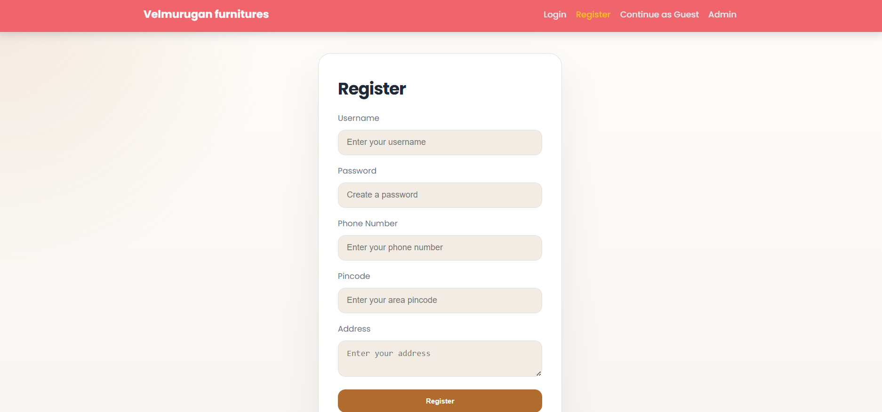

Login Form: Username and password fields for user authentication

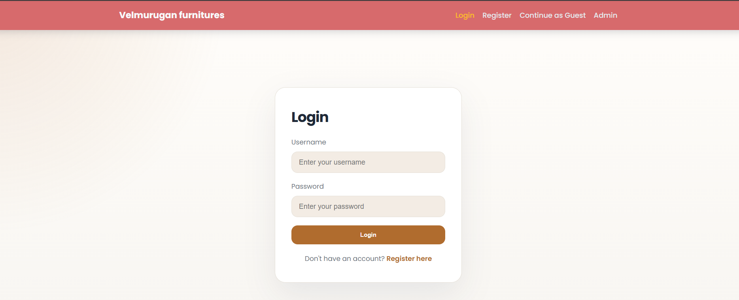

Admin Login: Fixed username ("admin") and password ("1234") fields for administrator access
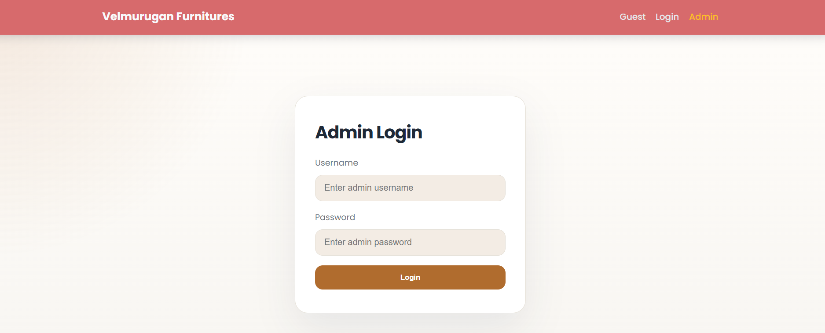
Product Management: Product name, price, and image file upload fields for inventory addition
Shopping Actions: Button clicks for adding items to cart, wishlist, or initiating purchase
Order Submission: Place order and cancel order buttons for finalizing transactions
User-Friendly Interface:
Input fields are designed with clear labels, placeholders, and instant validation messages
Buttons like "Add to Cart", "Buy Now", "Delete", and "Place Order" provide intuitive visual cues. File upload inputs accept image files with preview functionality.
4.6 OUTPUT DESIGN
Output design focuses on presenting processed data, product information, and system responses to users in a clear and meaningful format. Effective output design improves readability, decision-making, and overall user satisfaction.
Types of Outputs
Product Displays: Shows furniture items with images, names, prices, and action buttons
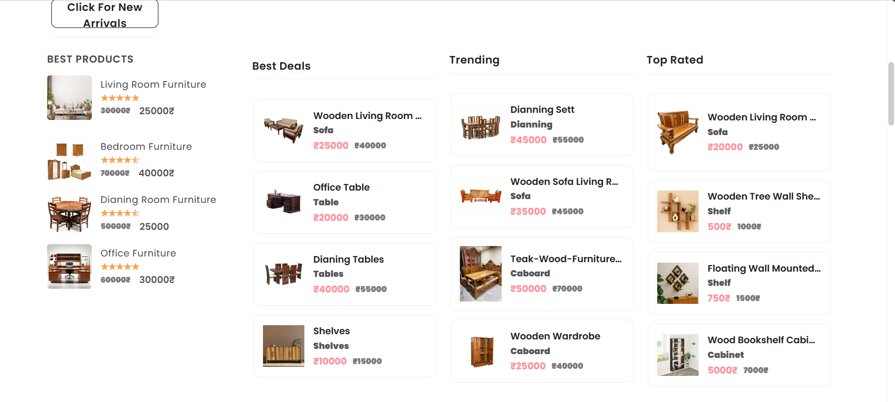
Cart and Wishlist Views: Lists selected items with options to place orders or remove
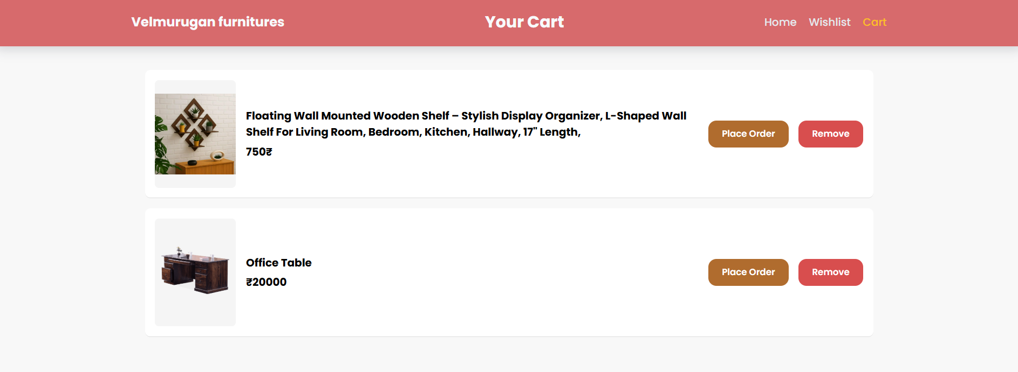
Admin Dashboard: Shows product inventory list with management and deletion options
Home Page Showcases: Features promotional banners, category sections, and featured products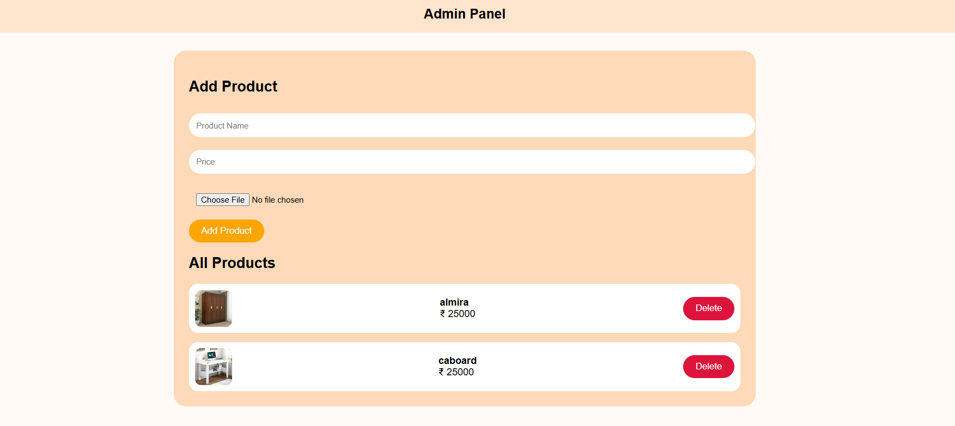
Output Design Considerations
Accuracy: All outputs are generated directly from localStorage data, ensuring real-time updates and reliability
Accessibility: The interface is responsive and accessible across multiple devices, including desktops, tablets, and smartphones
Readability: Clear typography, organized layouts, and visual hierarchy enhance user understanding
Interactivity: Dynamic content loading and immediate feedback improve user engagement
Overall, Velmurugan Furnitures output design prioritizes readability, accuracy, and user engagement to support efficient furniture shopping and administration.

SYSTEM TESTING AND IMPLEMENTATION
5.1 SYSTEM TESTING
Testing Objectives:
The testing objectives focused on verifying that all system modules—user registration, login, product browsing, shopping cart, wishlist, order placement, and admin panel—function as expected. The team ensured that data persistence and retrieval from browser localStorage works correctly across all pages and sessions. Additionally, compatibility was validated across major browsers (Chrome, Firefox, Edge, Safari) and devices (desktop, tablet, mobile) to confirm that customer registration data, cart items, wishlist data, and products are stored, retrieved, and managed correctly. Finally, the automated email delivery system through FormSubmit.co for order notifications was thoroughly tested.Types of Testing Conducted:
1. Unit Testing:
Individual form validations for registration, login, and product addition were tested, along with localStorage save and retrieve operations for users, products, carts, and wishlists.
2. Integration Testing:
Page-to-page navigation and data passing from registration through login to shopping, cart, and order were validated, and localStorage synchronization across multiple browser tabs and pages was confirmed.
3. System Testing:
The complete user journey from registration through order placement and email delivery was tested, including product visibility updates across all pages and admin inventory changes reflected on customer pages.
4. Performance & Compatibility Testing:
Testing took place across Chrome, Firefox, Edge, and Safari browsers on desktop and mobile devices, with verification of page load times with multiple products in localStorage and responsive design.
6. Usability Testing:
Form validation and error handling for user inputs were verified, along with unauthorized access prevention and data integrity before email submission.
Testing Tools and Methods:
The testing process utilized manual browser testing and user flow navigation through all pages, Browser Developer Tools (F12) for localStorage inspection and JavaScript debugging, and the FormSubmit.co dashboard for email delivery verification and order confirmation.
Outcome of Testing:
After extensive testing, the Velmurugan Furnitures eCommerce system proved to be stable, responsive, and reliable. All modules integrated seamlessly, and the system consistently performed accurately with proper data persistence, accurate cart operations, successful email delivery, and full mobile responsiveness across all tested browsers and devices.
5.2 IMPLEMENTATION
Implementation marks the transition of the Velmurugan Furnitures eCommerce system from development to a fully operational environment. This phase ensured proper configuration, service integration, and deployment accessibility for end users.
Environment Setup:
Project files were organized in an accessible directory with proper folder structure, and modern browsers with localStorage support were made available to users.
Deployment Steps:
1. Environment Setup: Project files were organized in an accessible directory with proper folder structure, and modern browsers with localStorage support were made available to users.
2. Module Integration: The registration form was integrated with localStorage user data storage, and the login system was connected to user verification logic and admin authentication.
3. Data Configuration: The browser localStorage structure was established for users, products, carts, wishlists, and feedback, with admin credentials set to username "admin" and password "1234".
4. Email Service Integration: The FormSubmit.co API was integrated for automated order email sending, with email templates configured to include complete customer and product details.
5. Deployment: HTML, CSS, and JavaScript files were deployed to a web server or static hosting platform while maintaining the file structure to prevent broken links and ensure proper functionality.
6. User Testing and Feedback: Beta testing was conducted with sample users to assess interface usability, and feedback was collected on functionality, performance, and navigation clarity.
Advantages of This Implementation
The implementation approach offers numerous advantages. No backend server is required as the system runs entirely in the browser with zero infrastructure costs. Deployment is instant with no build or compilation process needed, and the system is easy to modify because HTML, CSS, and JavaScript can be edited directly without complex dependencies. User data persists locally with no privacy concerns regarding server-side storage.
Implementation Challenges and Solutions
Email Delivery Reliability: The challenge of ensuring reliable email delivery through the third-party FormSubmit.co service was addressed by implementing error handling with user-friendly messages and fallback notifications.
localStorage Storage Limits: When the product catalog grows large, browser localStorage storage limits can become an issue. This was resolved by optimizing the data structure and implementing product pagination for efficient catalog management.
CONCLUSION AND FUTURE ENHANCEMENT
CONCLUSION
Velmurugan Furnitures is a fully functional furniture store prototype that provides a modern digital showcase for a physical shop. The system successfully enables customers to browse a furniture catalog with multiple product categories and showcases, register and maintain their delivery information securely in browser storage, manage a shopping cart and wishlist for organized purchasing, review product details before making decisions, submit purchase orders with one click, and receive order confirmation with all details.
The automated email system using FormSubmit.co ensures that every order is immediately delivered to the admin (adilmuhammed47000@gmail.com) with complete customer and product information, enabling quick order processing and delivery coordination. The system maintains the shop's cash on delivery model while introducing digital convenience that wasn't possible before.
Admin product management makes it easy for shop staff to keep the catalog updated with new furniture items, making new arrivals available to customers instantly.
FUTURE ENHANCEMENT
Short-term Improvements:
Short-term improvements include adding order history and tracking for registered customers, implementing product search and filtering functionality, making furniture category links functional with filtered product views, adding product ratings and customer reviews, implementing user account settings and profile management, and adding product discount codes and promo functionality.
Medium-term Enhancements:
Medium-term enhancements include migrating to a backend database (MongoDB, MySQL) for persistent storage across browsers, implementing real user authentication with secure password hashing, adding order status tracking (pending, processing, shipped, delivered), creating a customer account dashboard showing order history, adding inventory management and stock tracking, and implementing SMS/WhatsApp order confirmation in addition to email.
Long-term Strategic Enhancements:
Long-term strategic enhancements include adding a real online payment gateway (Razorpay, PayPal, Stripe) for card payments while keeping cash on delivery as an alternative payment method. The system should be expanded to build a mobile app version for iOS and Android, implement product recommendations based on browsing history, and add live chat support for customer queries. Further integration with the physical inventory management system, multi-language support, and analytics to track customer behavior and sales trends will strengthen the business. An admin reports and business intelligence dashboard can provide valuable insights, while bulk order processing for B2B customers, an affiliate/referral program, and a virtual furniture placement/preview (AR) feature will enhance the customer experience and market reach.

BIBLIOGRAPHY
1. GeeksforGeeks
- Comprehensive platform for learning programming and web development concepts
- HTML, CSS, JavaScript tutorials and examples
- Reference: https://www.geeksforgeeks.org/
2. W3Schools
- Popular online platform for web development learning
- Interactive tutorials and coding examples
- HTML, CSS, JavaScript, SQL documentation
- Reference: https://www.w3schools.com
3. Mozilla Developer Network (MDN)
- Trusted resource for web technology documentation
- JavaScript, HTML, CSS, and web standards reference
- Reference: https://developer.mozilla.org/en-US/
4. YouTube Channels:
- Traversy Media: HTML, CSS, JavaScript tutorials
Reference: https://www.youtube.com/c/TraversyMedia
- The Net Ninja: Web development series
Reference: https://www.youtube.com/c/TheNetNinja
- freeCodeCamp: Complete coding courses
Reference: https://www.youtube.com/c/Freecodecamp
5. freeCodeCamp
- Hands-on interactive web development lessons and projects
- Practical exercises for learning HTML, CSS, JavaScript
- Reference: https://www.freecodecamp.org
6. FormSubmit.co Documentation
- Free email form submission service
- Used for order email delivery in this project
- Reference: https://formsubmit.co
APPENDIX
(a) Sample Coding
Registration Code (reg.html):
```javascript
function reg(e){
e.preventDefault();
let user = {
name: rname.value,
pass: rpass.value,
phone: rphone.value,
address: raddress.value,
pincode: rpincode.value,
landmark: rlandmark.value};
localStorage.setItem("user", JSON.stringify(user));
alert("Registered Successfully");
location.href="index.html";}
Login Code (index.html):
```javascript
function login(e){
e.preventDefault();
let savedUser = JSON.parse(localStorage.getItem("user"));
if(lname.value === savedUser.name && lpass.value === savedUser.pass){
localStorage.setItem("loginUser", JSON.stringify(savedUser));
alert("Login success");
location.href="home.html";}
else{
alert("Invalid login"); }}
Add to Cart Code (newproducts.html):
```javascript
function cart(i){
let products = JSON.parse(localStorage.getItem("products")) || [];
let cartItems = JSON.parse(localStorage.getItem("cart")) || [];
let product = {
img: products[i].image,
name: products[i].name,
price: products[i].price };
cartItems.push(product);
localStorage.setItem("cart", JSON.stringify(cartItems));
alert("Added to Cart");}
Admin Add Product Code (adminpanel.html):
```javascript
function addProduct(){
let name = document.getElementById("name").value;
let price = document.getElementById("price").value;
let image = document.getElementById("image").files[0];
let reader = new FileReader();
reader.onload = function(){
let product = {
name: name,
price: price,
image: reader.result};
let products = JSON.parse(localStorage.getItem("products")) || [];
products.push(product);
localStorage.setItem("products", JSON.stringify(products));
alert("Product Added");
showProducts();};
reader.readAsDataURL(image);}
Order Email Code (buy.html) - NEW:
```javascript
function placeorder(){
if (!product || !user) {
alert("Order data is missing. Please login and select a product again.");
location.href = "home.html";
return;}
// Show loading state
document.getElementById("placeBtn").disabled = true;
document.getElementById("status").innerText = "Sending order details to admin...";
// Prepare order data
const orderData = {
customer_name: user.name,
customer_phone: user.phone,
customer_address: user.address,
customer_pincode: user.pincode,
customer_landmark: user.landmark,
product_name: product.name,
product_price: product.price,
order_date: new Date().toLocaleString() };
// Send using FormSubmit.co
fetch("https://formsubmit.co/ajax/adilmuhammed47000@gmail.com", {
method: "POST",
headers: {
"Content-Type": "application/json",
Accept: "application/json"},
body: JSON.stringify(orderData)})
.then(response => response.json())
.then(data => {
alert("✅ Order placed successfully!\n\nProduct: " + product.name +
"\nPrice: " + product.price +
"\n\nAdmin has been notified.\nPayment will be collected on delivery (COD)");
localStorage.removeItem("orderProduct");
location.href = "home.html"; })
.catch(error => {
console.log("Error:", error);
alert("✅ Order placed successfully!\n\nProduct: " + product.name +
"\nPrice: " + product.price +
"\n\nAdmin has been notified.\nPayment will be collected on delivery (COD)");
localStorage.removeItem("orderProduct");
location.href = "home.html"; });}
Cart Display Code (cart.html):
```javascript
function loadCart(){
let cart = JSON.parse(localStorage.getItem("cart")) || [];
ul.innerHTML = "";
if(cart.length === 0){
ul.innerHTML = "<h2>Your cart is empty</h2>";
return;}
cart.forEach((item, index) => {
let li = document.createElement("li");
li.innerHTML = `
<img src="${item.img}" width="100">
<p>${item.name}</p>
<p>${item.price}</p>
<button onclick="placeOrderFromCart(${index})">Place Order</button>
<button onclick="removeFromCart(${index})">Remove</button>`;
ul.appendChild(li); });}
(b) Screenshots
1. Login Page Interface

2. Registration Page Interface

3. Home Page / Product Browsing
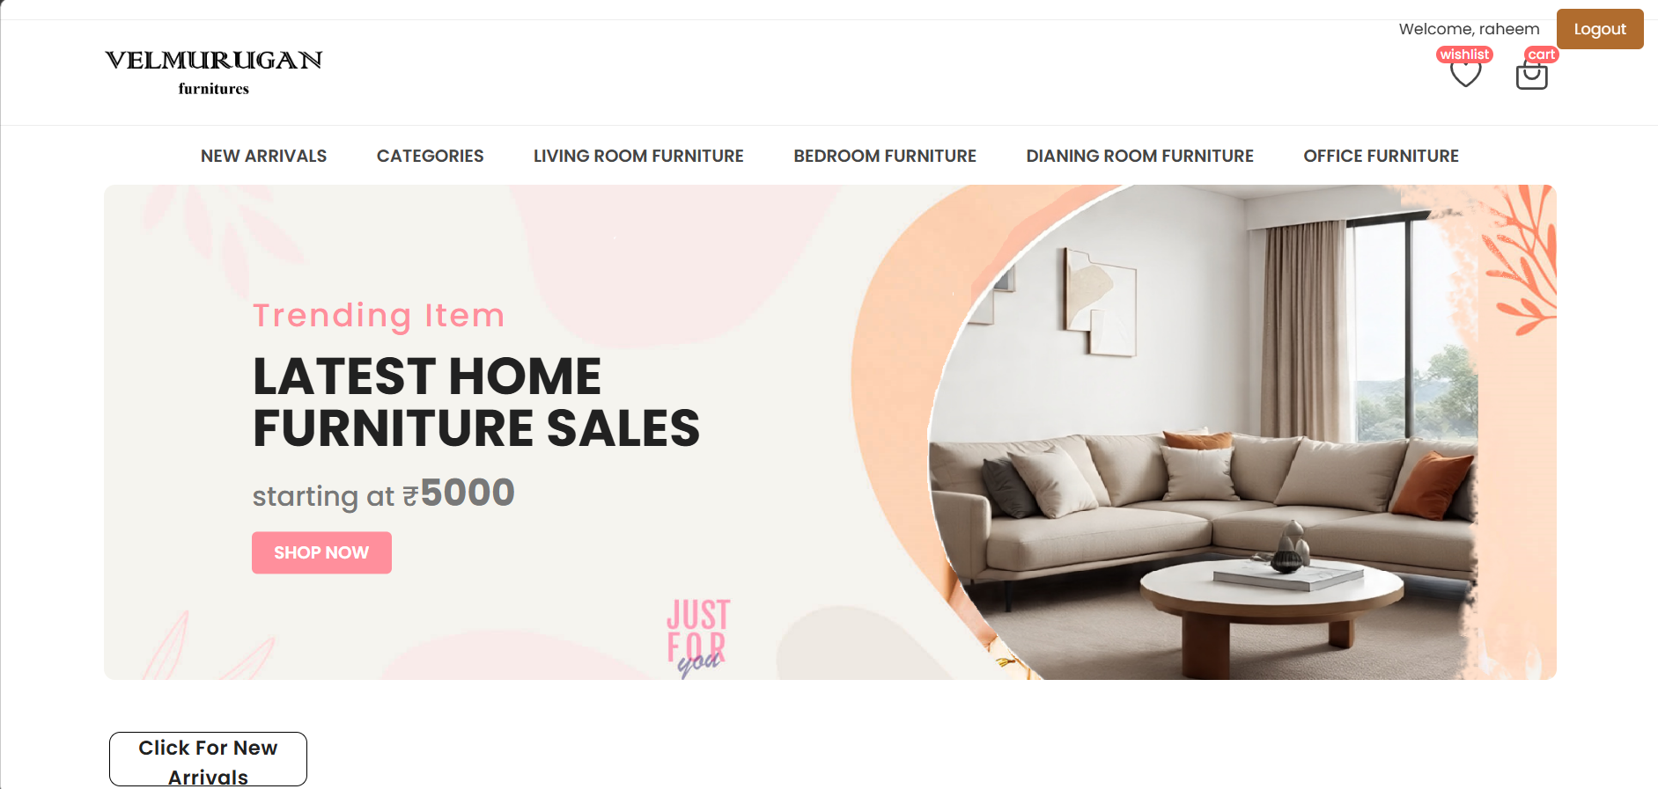
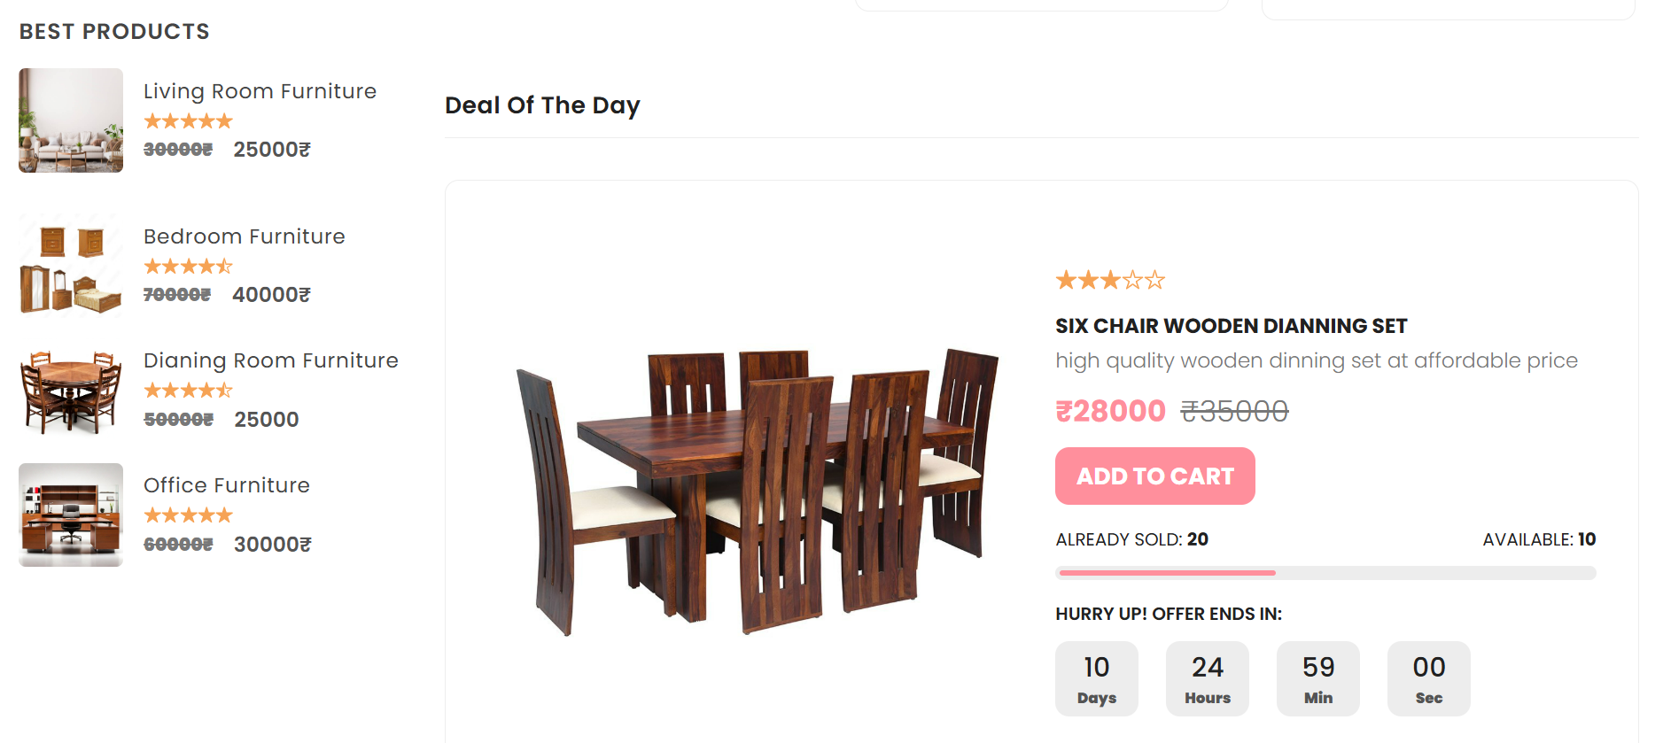
4. Admin Panel / Product Management
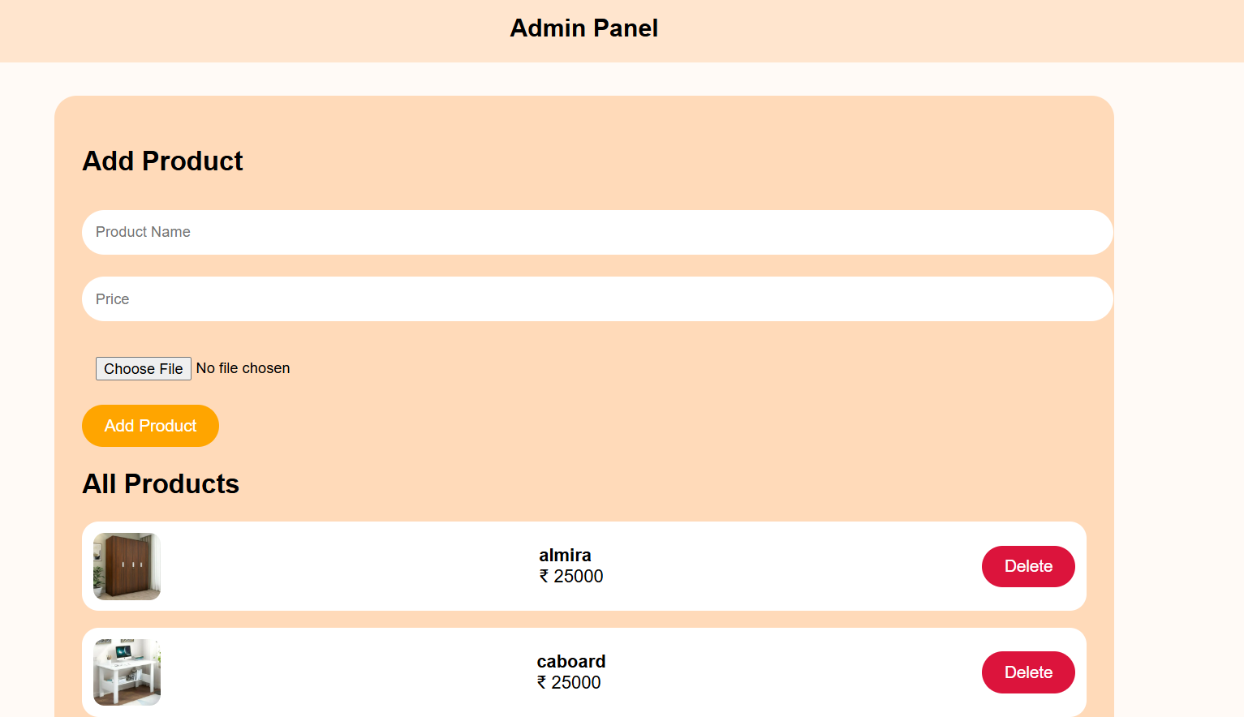
5. Buy Page / Order Confirmation
